BERLIOZ REQUIEM NEWSLETTER NO. 5
4th JULY 2018
Reply to Jos Gregson,
18 Willoughby Close,
Alveston,
Bristol BS35 3RW
Tel: 01454-411652
Email: jos@josgregson.plus.com

Dear Singer
This is being sent to you because you have signed up to take part in the Berlioz Requiem performance in Gloucester Cathedral on July 14th 2018 as part of the Cheltenham Music Festival. Rehearsals are now in full swing with the first five having taken place, three more this week and five next week.
SUPPORT
Despite the Workshop being mandatory a very disappointing 35 singers failed to turn up on June 30th. You may know the Berlioz Requiem intimately but we are all in this together and are looking for the better and more professional singers to support those from non-audition choirs who need more back-up.
SCORES
I still have a very few new copies should you wish to upgrade from a hire copy to your own copy, price £15..

RETURN OF SCORES
Boxes will be available for the return of scores at the end of the concert. These will be located on both sides of the stage area, please return your scores to these boxes. There will also be additional boxes and members of the committee at the South and West doors to recover any loan scores that singers fail to hand in. I do not want to have to make phone calls to recover hire scores so please hand them in after the concert.

CONCERT WEAR
Gentlemen – Dinner jackets/black suits, white shirts, black bow ties.
Ladies – Long black trousers/skirts, black tops with three quarter or long sleeves (no short sleeves or sleeveless tops).

FOLDERS
We will not be using folders, we have all got uniform light blue Bärenreiter scores so will use these without folders. If you are one of the two or three who are singing from either Kalmus or Schirmer see me as I have got spare Bärenreiter scores for you to put around your scores so that they all look uniform from the audience’s point of view.

BUSES
The SCBSG will run buses from Thornbury to the Gloucester rehearsals and the performance. The dates and departure times are as listed below together with the costs. If you want to reserve a ticket on a bus please let me know at jos@josgregson.plus.com This will obviously suit members of Nailsea, Portishead, Thornbury, Yate, Bristol and Monmouth Choral Societies. There are some places left if you want to take them up, contact me as above.

All departures will be from outside Aldi in Thornbury.

Margaret Pinder will be Coach Monitor, her mobile number is 07753 162920

July 4th Rehearsal Crypt School departure 18.15 leave Crypt School at 21.45. Cost £6
July 11th Rehearsal Crypt School departure 18.15 leave Crypt School at 21.45. Cost £6
July 13th Rehearsal Gloucester Cathedral departure 18.15, leave Gloucester Cathedral at 21.45. Cost £6
July 14th Rehearsal and performance Gloucester Cathedral departure 12.45, leave Gloucester Cathedral at 21.45. Cost £8

Please pay either by BACS to SCBSG sort code 55-61-38 Account 72408375 or by cheque made out to SCBSG to Jos Gregson, 18 Willoughby Close, Alveston, Bristol BS35 3RW

PERFORMANCE TICKETS
SCBSG have been allocated a number of tickets for sale at £35, £28, £22 and £15, the latter are aisle seats with limited visibility. The number of tickets that we have for sale is limited. Jos will have any remaining tickets with him for sale at all the rehearsals or alternatively by phone or email as at the top of this Newsletter. Payment may be paid by cheque or BACS (details as listed under buses above).

QUERIES
If you have any questions or there is anything that you wish to discuss please do not hesitate to contact me using the contact details above.

REHEARSAL SCHEDULE
The up to date schedule is given below as a record. You will be notified in good time of any changes in timings or venues. There will be checking in at all rehearsals apart from 14th July

SOUTH COTSWOLD BIG SING GROUP
BERLIOZ REQUIEM 2018 REHEARSAL SCHEDULE
DATE | EVENT | TIME | VENUE | Conductor | Accompanist
3/7/18  Tuesday | Rehearsal | 7.30-9.30pm | Wycliffe Junior School  Performing Arts C | Chris Swain | George Gillow
4/7/18  Wednesday | Group  Rehearsal | 7.30-9.30pm | Crypt School, Gloucester | Adrian Partington | Robin Baggs
5/7/18  Thursday | Rehearsal | 7.30-9.30pm | Alveston Methodist Church | Steven Kings | Robin Baggs
10/7/18  Tuesday | Rehearsal | 7.30-9.30pm | Wycliffe College  Chapel | Chris Swain | George Gillow
11/7/18  Wednesday | Group  Rehearsal | 7.30-9.30pm | Crypt School, Gloucester | Adrian Partington | Jonathan Hope
12/7/18  Thursday | Rehearsal | 7.30-9.30pm | Alveston Methodist Church | Steven Kings | Robin Baggs
13/7/18  Friday | Group Rehearsal | 7.30-9.30pm | Gloucester Cathedral | Adrian Partington | Jonathan Hope
14/7/18  Saturday | Group Rehearsal | 2pm-5pm | Gloucester Cathedral | Adrian Partington | British Sinfonietta
14/7/18  Saturday | Performance | 7.30pm-9.15pm | Gloucester Cathedral | Adrian Partington | British Sinfonietta

SEATING ARRANGEMENTS
Having tried several versions we have arrived at the lay out below for the concert performance. At the first cathedral rehearsal we shall fix the precise seating arrangements but it would be helpful if members sit in equivalent positions in the earlier Crypt School rehearsals. There are a number of practical issues which you should be aware of ahead of times to reduce the time spent sorting things out in the cathedral. We shall sit in voice parts as shown below:
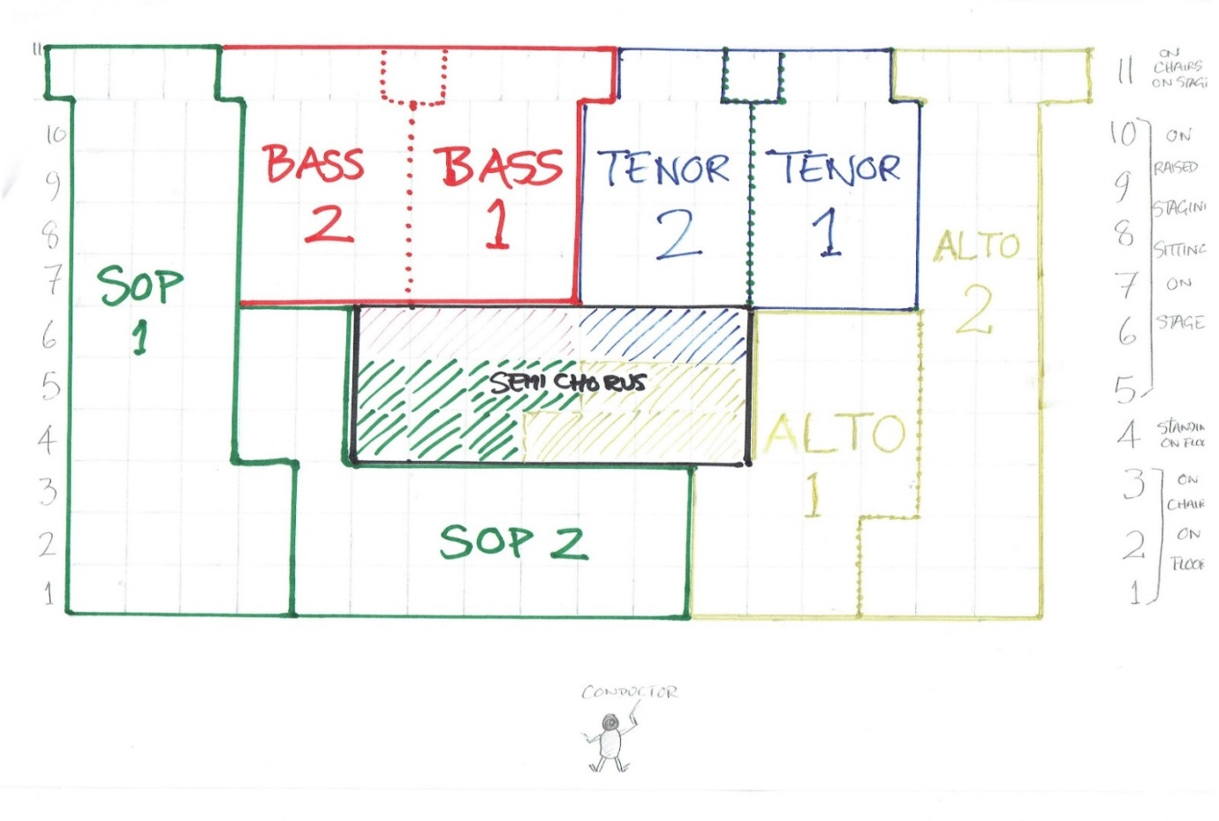
There are seven rows on raised seating at the back and four rows standing on the floor, three on seats on the floor and one sitting on the bottom layer of the raised seating but standing on the floor. There is scope for various problematic issues:
1. The higher rows on the raised seating are actually quite a way off the ground and anyone with a poor head for heights should avoid these.
2. The floor level rows are quite a long way from the conductor and although he will have a well raised dais it will be critical for good visibility that these rows are graded in ascending height order, so we suggest height ranges for these ladies as follows:
Front row < 5ft 2”
Row 2 to 5ft 5”
Row 3 to 5ft 7”
Row 4 > 5ft 7”
3. Those who are keen to sit next to someone in a different height band should sit on the raised seating where there is a 20” step up between each row and height is more or less irrelevant

TIMINGS
Rehearsals:
Friday 13 July: Please be assembled in the cathedral seated and ready to sing by 7.30pm. allowing for the possibility that it will take a while to get everyone seated correctly. The Concert Manager and his Deputy will have seats labelled, once you have done this rehearsal this will be your singing position on 14th July

Saturday 14 July: Please be assembled on stage in the cathedral ready to sing at 2.00pm. We will be using the Parliament Suite to leave our clothes etc.in. Coming into the Cathedral yard pass the Cathedral West Door and the Parliament Suite is directly ahead of you and should be labelled. There are three rooms – that facing on to the Cathedral Yard will be the Ladies changing room, the centre room will be for refreshments and eating your supper, the room at the back will be the Gentleman’s changing room

Concert:
Please be assembled in the cathedral transepts by 7.15, ready to move on to stage, see below. Please note that the Green rooms will be locked from 7.15. Despite varying information given out the concert starts at 7.30pm

Choir Entry, Standing & Sitting Arrangements:

1. The choir will enter from both sides with odd number rows entering from the north transept
and even number rows entering from the south, filling the lower, front rows first.
2. On initial entry we shall remain standing until all are in and a designated person on the front row signals us to sit.
3. We will stand up with the orchestral leader on entry of the conductor.
4. During the concert we will sit and stand as directed by the conductor.
5. At the end of the concert we will remain standing until the conductor goes out, when we
shall sit. We remain seated when he re-enters unless/until the conductor signals us to stand.
6. Whilst standing we are receiving applause so do not applaud ourselves u nless the
conductor singles out the soloist or members of the orchestra. Whilst seated we join the
audience in applauding the conductor & soloist.
7. When all applause has finished and the conductor has departed, the choir will leave the
stage in the reverse order in which they entered – that is the top rows will exit first.

REFRESHMENTS AND BREAKS AT REHEARSALS AND ON CONCERT DAY
Squash and water will be provided at the two remaining rehearsals at Stonehouse and the three at Alveston.

There will be a ten minute break at around 8.30pm on 4th, 11th and 13th July

There will be a 15 minute break on concert day, 14th July. This will be at 3.35pm

Please bring any (non-alcoholic) drinks you require to all the rehearsals at the Crypt School and the Cathedral – these rehearsals are for 200 singers and it would take too long to provide juice etc. to everyone.

There is only going to be a very brief break in the concert after the Lacrimosa, not an interval. Please feel free to bring a discreet water bottle into the concert, preferably not in fluorescent colours and magnum sized! We do want to look professional.

REHEARSAL VENUES

WYCLIFFE COLLEGE CHAPEL
The rehearsal on 10th July will be at Wycliffe College Chapel, Bath Road, Stonehouse GL10 2JQ.
Note that the following are revised instructions from Newsletter No. 3
There is parking in the grounds of the main school either side of the drive way and an extra car park in front of the headmaster’s house
The entrance is on the left before the fifth roundabout
There will be a steward to show people where to go.

ALVESTON METHODIST CHURCH
On June 28th, July 5th and July 12th Steven Kings will take rehearsals at Alveston Methodist Church, Alveston, BS35 3RY at 7.30pm.
Coming out of Bristol take the A38 – after you pass the village sign saying ALVESTON St Helen’s Church is on your left. Turn left immediately after St Helen’s Church, Alveston Methodist Church is around 400 yards on the left on the corner of Wolfridge Ride.
Coming from the Stroud and Gloucester direction on the A38 go through the lights signed to Thornbury and immediately get into the right hand lane. Turn right into David’s Lane, drive to the T junction at the bottom, turn left and immediately right and Alveston Methodist is up to your left.
CRYPT SCHOOL, GLOUCESTER
On 4th July and 11th July there will be mandatory rehearsals at The Crypt School, Podsmead Road, Gloucester GL2 5AE from 7.30pm-9.30pm to be taken by Adrian Partington.
Coming from Junction 12 on the M5 follow signs to Gloucester city centre on the dual carriageway. Cross two roundabouts and at the major lights that are next turn right on the A38 to Gloucester City Centre. After around 800 yards Podsmead is on the left at lights. Turn left, go round a small roundabout and drive into the Crypt School driveway. There will be sufficient parking at the front of the school as we are the only group using the school those evenings. If you need to you may park on the grass at the front of the school.
GLOUCESTER CATHEDRAL
Very well signposted with brown signs from outside Gloucester. There is a large car park in Westgate Street as you leave the inner bypass to turn left towards the Cathedral
All the best and I look forward to meeting up with all of you at rehearsals.
Jos Gregson
Chairman
South Cotswold Big Sing Group

